European Bike Sharing Analysis

Summary

“The analysis reveals uneven bike distribution, high demand in certain stations, and opportunities to improve efficiency through better resource allocation and real-time monitoring.”

Key Insights
- Some stations have very low or zero available bikes, indicating high demand
- Several stations are fully occupied, meaning no empty stands
- Bike distribution is uneven across cities
- High utilization rate shows strong usage in certain areas
- Some stations consistently show low usage, indicating inefficiency
Main Objective
- To analyze bike station availability, capacity, and utilization to improve operational efficiency and support better decision-making.
Detailed Objectives
- Analyze Bike Availability
  - Monitor available bikes at each station
  - Identify stations with low or no bikes
- Evaluate Station Capacity
  - Compare total stands vs available stands
  - Understand how stations are utilized
- Measure Utilization Rate
  - Calculate occupancy percentage
  - Identify high-demand stations
- Identify Availability Issues
  - Detect:
    - Empty stations
    - Low availability stations
    - Fully occupied stations
- Location-Based Analysis
  - Compare stations across cities (Contract Name)
  - Identify uneven distribution
- Time-Based Analysis
  - Analyze trends using Last Update
  - Identify peak and low usage periods
- Build Interactive Dashboard
  - Use charts, KPIs, and maps
  - Enable filtering with slicers

Data Modelling

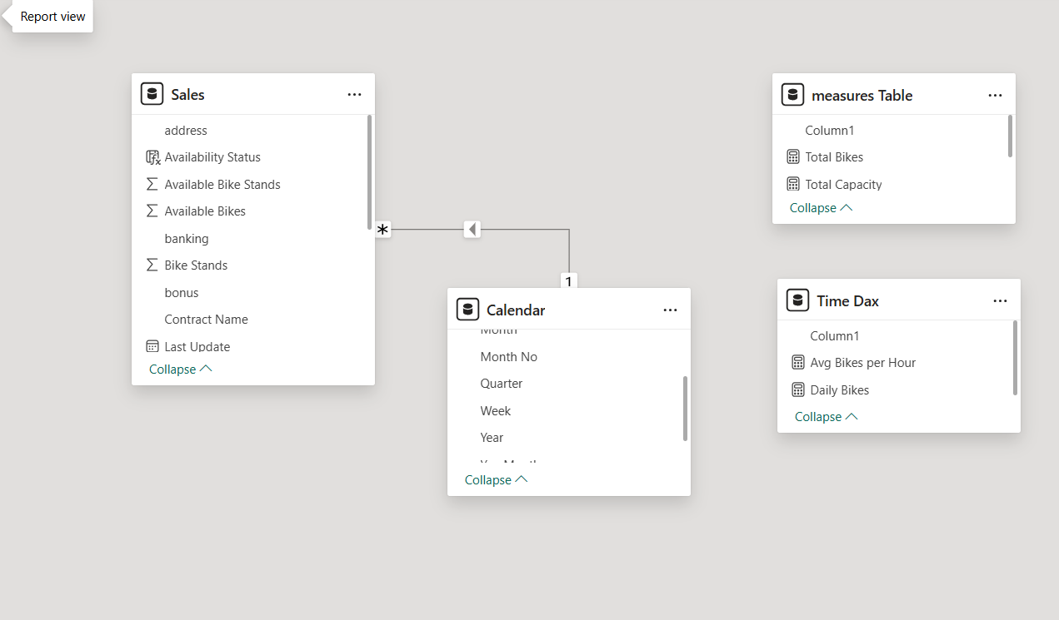

Dashboard Features

Line Chart (Trend Analysis)
- Bar Chart (City Comparison)
- Column Chart (Station Performance)
- Map Visualization

Filter & Slicer Panel
- Pie Chart (Availability Status)
- Detailed Data Table
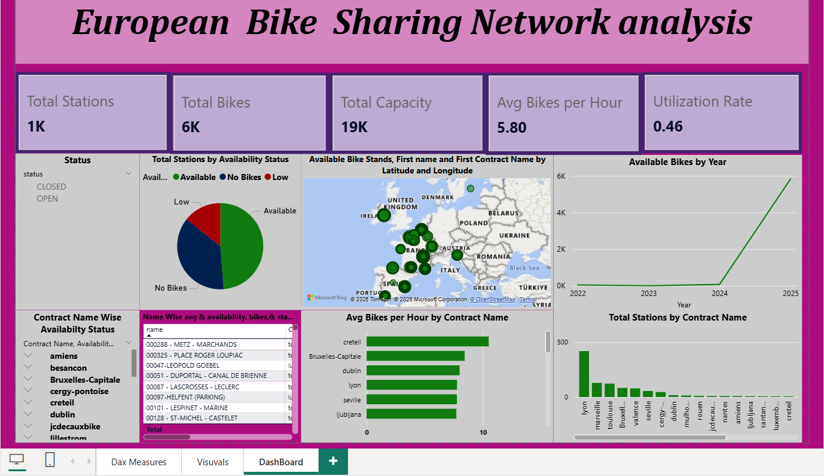

Final Conclution
The Bike Station Analysis dashboard provides a comprehensive view of station performance by analyzing bike availability, capacity, and utilization across different locations and time periods. The analysis highlights key challenges such as uneven bike distribution, low availability in high-demand stations, and underutilization in certain areas. Through interactive visualizations and KPI metrics, the dashboard enables clear identification of usage patterns and operational inefficiencies. The insights derived from this analysis support data-driven decision-making, allowing for effective bike redistribution, optimized station capacity, and improved service efficiency. Overall, this project demonstrates how Power BI can be used to transform raw data into meaningful insights for enhancing urban mobility and resource management.

